**Purpose of Code**: Stiffness method is a very systematic method for analysing determinate and indeterminate structures. It expresses local(member) force-displacement relationships in terms of unknown member displacements. This method determines the unknown displacements using equilibrium of assembled member. Unknowns are usually displacements. It directly gives desired displacement and internal member forces.

The calculation by this method is easy with pen-paper for nodes up to 5. But what if you are given 10 node or 20 node or even more, the calculation become very tedious. So, we can write a code for this method as it is easy to program in a computer.

Let’s walkthrough the code using an example problem

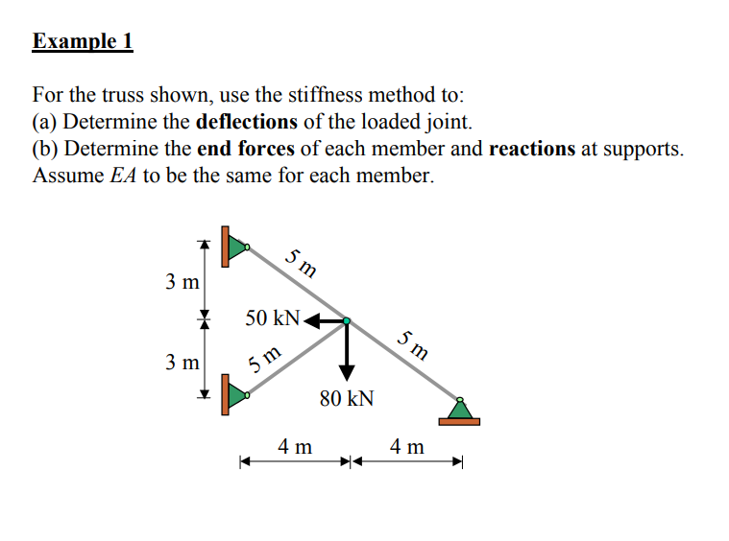

Following steps are required to give the input to the code in correct manner.

**Step-1**: Calculate the number of nodes and member in the given problem. In the example problem, number of nodes = 4 and number of members = 3.

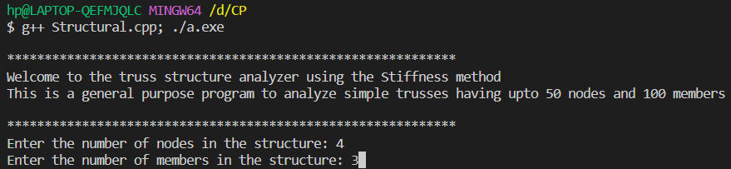

**Step-2:** Now, we have to assign the coordinate on each node. You may assign coordinate by taking any node as origin(reference). But the code is written based on a defined node assignment rule that you should label the starting node value to the node where forces are known to us.

In the example problem, we have given the node 1 where forces are known.

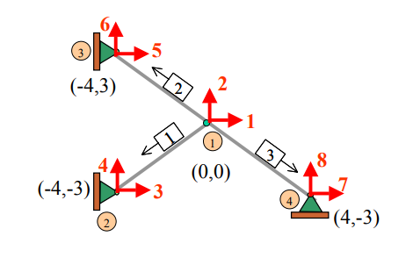

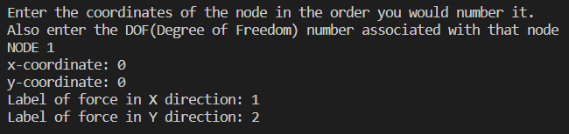

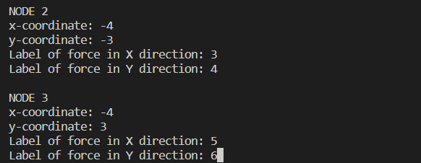

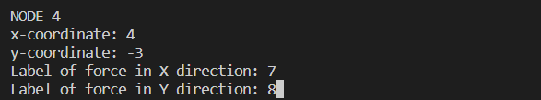

**Step-3:** Now, we have to specify the connectivity between nodes i.e. the member force between the two nodes

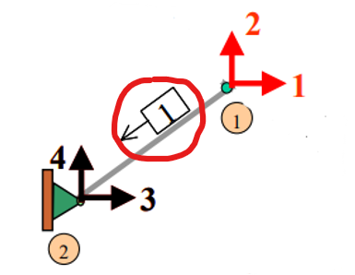

For the code demonstration purpose, we have taken A = 1m.2 and E = 1 (which can be later changed in code according to the purpose)

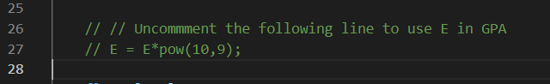

We are assuming the direction of member is compressive in nature from node 1 which is defined as **near node** in code and node where arrow is pointed is **far node**.

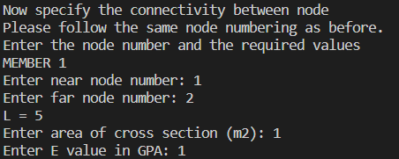

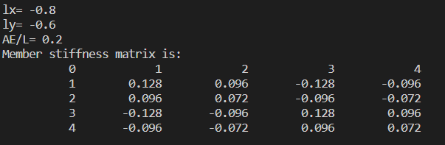

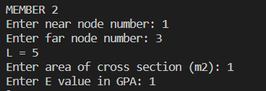

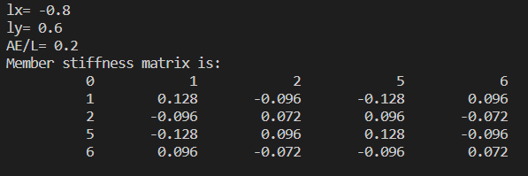

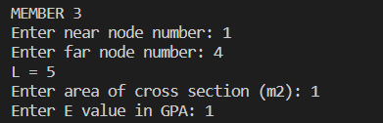

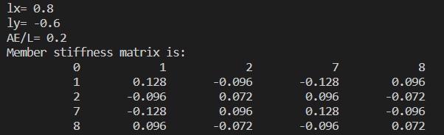

**Step-4:** Now, the code will generate the Global Stiffness matrix as follows:

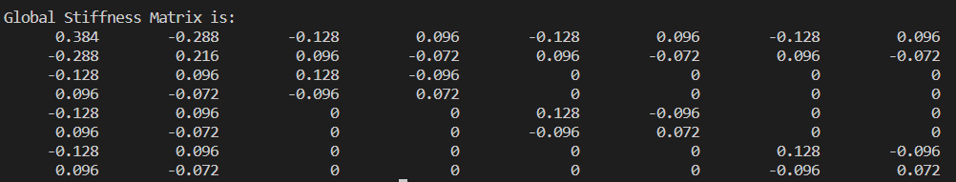

**Step-5:** As mentioned earlier, the code is written based on a defined node assignment rule that you should label the starting node value to the node where forces are known to us.

Now, the number of known forces is -50 kN at node 1 and -80 kN at node 2. The unknown displacements are at node 1 and 2. The known displacement are at node 3, 4, 5, 6, 7 and 8 which is zero since they are hinged i.e., fixed.

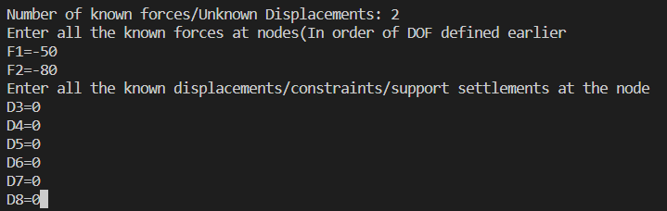

**Step-6:** Our code will find the unknown displacement with the help of known forces and inverse of the required portion of the Global Stiffness Matrix.

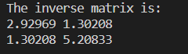

After finding the unknown displacement, the code will find all the unknown forces using the same the Global Stiffness Matrix.

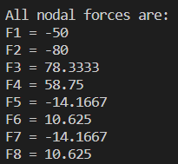

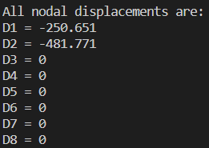

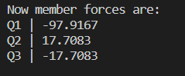

* The solution of the example problem matches with the solution obtained from the code:

1. Forces on each node as per label:

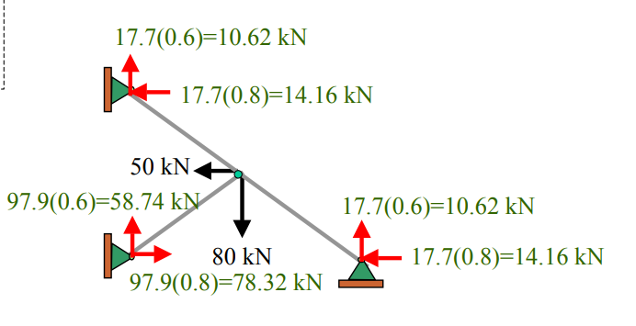

As mentioned earlier, For the code demonstration purpose, we have taken A = 1m.2 and E = 1 (which can be later changed in code according to the purpose)

1. Displacement at node

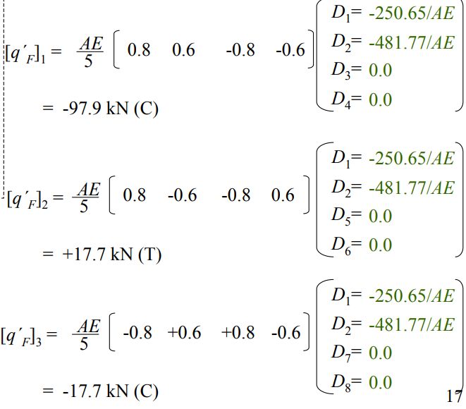

1. Force at each member with direction. (Note: force is negative in the code output since direction of force is opposite)

